**Job Type & Write Record**

**Author: Habibur**

1. **What is a job type**

Client needs statements in different ways. Client may want statement through email or print in white paper. Some customer may not have any valid email and physical address that bank can send statement to their address. So, after the job done (Data parse and Statement print) we have to differentiate the **afp** or pdf and **index fle**(Customer data in text format).

There are 3 major job type in business. But job type may increase based on business requirement.

1. Job type e
2. Job type f
3. Job type s

**1. Job Type s:** Most of customer needs statement by print from laser printer. So, Job type s determine to a process that, all the customer statement make in a large afp file also corresponding their index file. Index file contain customer account number, physical address, number of pages for print etc. By using this index file all the apf’s goes to a laser printer. Printer automatically print each customer by using these data and also separate the each statement. Statements are also sorted using index file. For instance, similar zip codes or area codes.

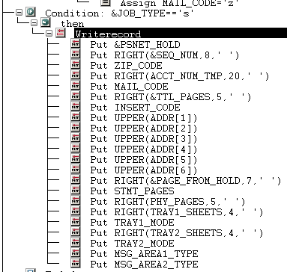

**This is how paper index file looks like. Every field is fixed length and has fixed position and alignment.** 

**2. Job Type f:** Some customer needs their statement to their email address instead of printing paper. So, We need to prepare the job like this. Generally we make individual afp file for each customer and a index file. Index file contain each customer afp name, account number, total pages and other information that, we can further process the afp by using this data and send pdf statement to their email address.

Index File for job type f

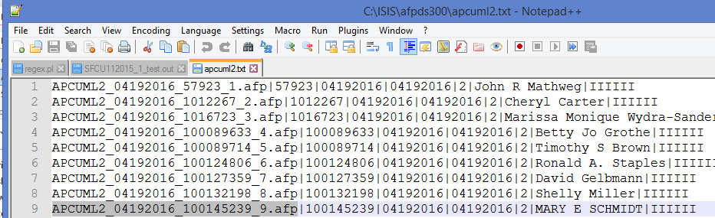

**3. Job Type e:** Some customer has no physical data to send their statement. Sometimes email address also may missing. Customer may appeal for statement to bank. So that kind of statement store to archive folder in bank. Clients needs to go to the bank to get their customer. Bank can search of his/her statement using index . And in dfa level those index are created and it gets embedded with the afp. From those index , index files are created at back end.

In Dfa:

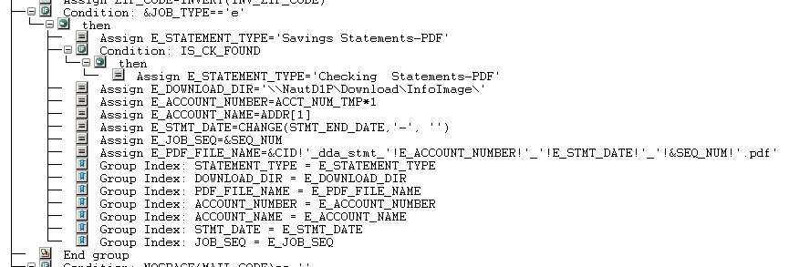

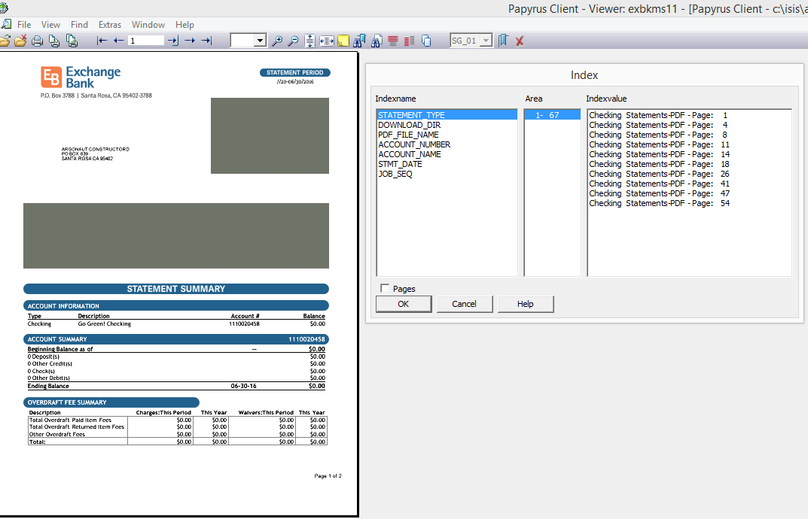

**How to create Index file/job type**

1. Declare two variable in system called JOB_TYPE=’f’ and ZIPFILENAME=’directory/projectinfo.txt’
2. Before Print anything write the following codes for job type f, s and e.

IF &JOB_TYPE=='f' ;

THEN ;

/****************variables definition for 'f' *************/

END_DATE_TMP = CHANGE(STATEMENT_DATE,'/', '') ;

IF $SYSTEM=='Windows' ;

THEN ;

OUTTEMP1 = 'c:\isis\afpds300\'!&PREFIX!'_'!END_DATE_TMP!'_'!

NUMPICTURE(LOAN_NUM,'#0')!'_'!&ACCT_SEQ!'.afp' ;

ELSE ;

OUTTEMP1 = '/'!&D_DIR!'/'!&CID!'/'!&PREFIX!'_'!END_DATE_TMP!'_'!

NUMPICTURE(LOAN_NUM,'#0')!'_'!&ACCT_SEQ!'.afp' ;

ENDIF ;

DUMMY = CHANGEENV('OUTFILENAME',OUTTEMP1) ;

SELECTOUTPUT OUTFILENAME;

ENDIF ;

3. After the print all document

IF &JOB_TYPE=='e' ;

THEN ;

/*Archival step*/

GROUPINDEX STARTING_DATE = ACCT_BEG_DATE ;

GROUPINDEX CLOSING_DATE = ACCT_END_DATE ;

GROUPINDEX ACCOUNT_PAGES = TTL_PAGES ;

GROUPINDEX JOB_SEQ = &ACCT_SEQ ;

GROUPINDEX PDF_FILE_NAME = PDF_NAME ;

GROUPINDEX ACCOUNT_NUMBER = ACCOUNT_NUM ;

GROUPINDEX ACCOUNT_NAME = NAME ;

GROUPINDEX INTERNAL = ACCOUNT_NUM ;

ENDGROUP ;

ELSE ;

IF &JOB_TYPE=='pdfi' ;

THEN ;

SLASH_FORMATT_DATE = SUBSTR(ACCT_BEG_DATE,1,2, '')!'/'!

SUBSTR(ACCT_BEG_DATE,3,2, '')!'/'!SUBSTR(ACCT_BEG_DATE,5,8,

'') ;

GROUPINDEX STARTING_DATE = ACCT_BEG_DATE ;

GROUPINDEX CLOSING_DATE = ACCT_END_DATE ;

GROUPINDEX ACCOUNT_PAGES = TTL_PAGES ;

GROUPINDEX JOB_SEQ = &ACCT_SEQ ;

GROUPINDEX ACCOUNT_NUMBER = ACCOUNT_NUM ;

GROUPINDEX ACCOUNT_NAME = NAME ;

ENDGROUP ;

WRITERECORD TO ZIPFILE ;

PUT 'Start' START *;

ENDIO;

WRITERECORD TO ZIPFILE ;

PUT 'FormName=Second Mortgage Statement' START *;

ENDIO;

WRITERECORD TO ZIPFILE ;

PUT 'DateFromDocument='!SLASH_FORMATT_DATE START *;

ENDIO;

WRITERECORD TO ZIPFILE ;

PUT 'MemberNumber='!ACCOUNT_NUM START *;

ENDIO;

WRITERECORD TO ZIPFILE ;

PUT 'ArchivalFile='!PDF_FILENAME START *;

ENDIO;

WRITERECORD TO ZIPFILE ;

PUT 'End' START *;

ENDIO;

WRITERECORD TO ZIPFILE ;

PUT ' ' START *;

ENDIO;

ELSE ;

GROUPINDEX ACCOUNT_NUMBER = LOAN_NUM ;

GROUPINDEX ACCOUNT_NAME = NAME ;

GROUPINDEX INTERNAL = ACCT_NUM ;

ENDGROUP ;

IF &JOB_TYPE=='s' ;

THEN ;

/****************writerecord variables definition for 's' *************/

&PSNET_HOLD = &PSNET_HOLD ;

&ACCT_SEQ = &ACCT_SEQ ;

ZIP_CODE = ZIP_CODE ;

ACCT_NUM = ACCT_NUM ;

MAIL_CODE = MAIL_CODE ;

&AC_IMAGE = &AC_IMAGE ;

INSERT_CODE = INSERT_CODE ;

FOR I

REPEAT 6 ;

ADDR[I] = ADDR_LINE[I] ;

ENDFOR ;

&PAGE_FROM_HOLD = &PAGE_FROM_HOLD ;

&LTR_CODE = &LTR_CODE ;

&AFP_CODE = &AFP_CODE ;

STMT_IMAGE_COUNT = &AC_IMAGE ;

&EOC_FLAG = &EOC_FLAG ;

GROUP_IMAGE_COUNT = &AC_IMAGE ;

ACCT_SHEET_COUNT = GROUP_SHEET_COUNT ;

TRAY1_SHEET_CNT = TRAY1_SHEET_CNT ;

TRAY2_SHEET_CNT = TRAY2_SHEET_CNT ;

TRAY1_MODE = 'd' ;

TRAY2_MODE = 'd' ;

/*paper*/

WRITERECORD TO ZIPFILE ;

PUT &PSNET_HOLD START 1 LENGTH 12;

PUT RIGHT(&ACCT_SEQ,8,' ') START 15 LENGTH 8;

PUT ZIP_CODE START 23 LENGTH 10;

PUT ACCT_NUM START 33 LENGTH 20;

PUT MAIL_CODE START 53 LENGTH 1;

PUT RIGHT(&AC_IMAGE,5,' ') START 54 LENGTH 5;

PUT INSERT_CODE START 59 LENGTH 5;

FOR I

REPEAT 6 ;

PUT UPPER(ADDR[I]) START * LENGTH 40;

ENDFOR ;

PUT RIGHT(&PAGE_FROM_HOLD,7,' ') START 304 LENGTH 7;

/*letter type: monthly or daily*/

PUT &LTR_CODE START 312 LENGTH 3;

PUT &AFP_CODE START 315 LENGTH 3;

PUT STMT_IMAGE_COUNT START 318 LENGTH 5;

PUT RIGHT(&EOC_FLAG,3,' ') START 332 LENGTH 3;

PUT GROUP_IMAGE_COUNT START 335 LENGTH 5;

PUT RIGHT(GROUP_SHEET_COUNT,5,' ') START 340 LENGTH 5;

PUT RIGHT(ACCT_SHEET_COUNT,5,' ') START 351 LENGTH 5;

PUT RIGHT(TRAY1_SHEET_CNT,4,' ') START 356 LENGTH 4;

PUT TRAY1_MODE START 360 LENGTH 1;

PUT RIGHT(TRAY2_SHEET_CNT,4,' ') START 361 LENGTH 4;

PUT TRAY2_MODE START 365 LENGTH 1;

ENDIO;

ELSE ;

/*estatement*/

IF &JOB_TYPE=='f' ;

THEN ;

/****************writerecord variables definition for 'f' *************/

END_DATE_TMP = CHANGE(STATEMENT_DATE,'/', '') ;

START_DATE_TMP = CHANGE(STATEMENT_DATE,'/', '') ;

ACCT_NUM = RIGHT(NUMPICTURE(LOAN_NUM,'#0'),20,' ') ;

&ACCT_SEQ = &ACCT_SEQ ;

&PREFIX = &PREFIX ;

TTL_PAGES = TTL_PAGES ;

NAME = ADDR_LINE[1] ;

WRITERECORD TO ZIPFILE ;

PUT &PREFIX!'_'!END_DATE_TMP!'_'!NUMPICTURE(ACCT_NUM,'#0')!

'_'!&ACCT_SEQ!'.afp|' START 1;

PUT NUMPICTURE(ACCT_NUM,'#0')!'|' START *;

PUT START_DATE_TMP!'|' START *;

PUT END_DATE_TMP!'|' START *;

PUT TTL_PAGES!'|' START *;

PUT NAME!'|' START *;

PUT 'I' START *;

PUT 'I' START *;

PUT 'I' START *;

PUT 'I' START *;

PUT 'I' START *;

PUT 'I' START *;

PUT '' START *;

ENDIO;

CLOSE OUTFILENAME;

ENDIF ;

ENDIF ;

ENDIF ;

ENDIF ;

**F.A.Q**

**---------**

1. What is a group index?

-Group Index are special variable information that embedded with a afp. Variable value embedded to afp that has no index file record. They needs to find out in future by these information.

1. Why to close outfilename?

-If outfilename does not close then all the customer data overwrite.

1. What is Write record?

-WriteRecord is a text file also known as index file. When write record block call, It write a line to index file of current customer.

**Coution:**

-Same name doc format needs to define in FormatGroup. Ex. OUTFILENAME or PDFOUT or ZIPFILE.

-One Put-Block create one separate line in index file.

-Make Sure to call EndGroup after GroupIndex.